**INTRODUCTION**

# 1. INTRODUCTION

The purpose of Car Rental System is a web application which provide the booking cars. The system is designed to handle all the activities of the company admin and users. The system will have the ability to search the information about cars and their amount per day. The database will be updated automatically in a real time manner. This system is for car rental so that primary users of the system are the users and companies.

The main users in this system are:

* Admin
* Users

**SYSTEM ANALYSIS**

# 2. SYSTEM ANALYSIS

System analysis is a process of gathering and interpreting facts, diagnosing problems and the information to recommend improvements on the system. It is a problem solving activity that requires intensive communication between the system users and system developers. System analysis or study is an important phase of any system development process. The system is studied to the minutest detail and analyzed. The system analyst plays the role of the interrogator and dwells deep into the working of the present system. The system is viewed as a whole and the input to the system are identified. The outputs from the organizations are traced to the various processes. System analysis is concerned with becoming aware of the problem, identifying the relevant and decisional variables, analyzing and synthesizing the various factors and determining an optimal or at least a satisfactory solution or program of action.

A detailed study of the process must be made by various techniques like interviews, questionnaires etc. The data collected by these sources must be scrutinized to arrive to a conclusion. The conclusion is an understanding of how the system functions. This system is called the existing system. Now the existing system is subjected to close study and problem areas are identified. The designer now functions as a problem solver and tries to sort out the difficulties that the enterprise faces. The solutions are given as proposals. The proposal is then weighed with the existing system analytically and the best one is selected. The proposal is presented to the user for an endorsement by the user. The proposal is reviewed on user request and suitable changes are made. This is loop that ends as soon as the user is satisfied with proposal.

Preliminary study is the process of gathering and interpreting facts, using the information for further studies on the system. Preliminary study is problem solving activity that requires intensive communication between the system users and system developers. It does various feasibility studies. In these studies a rough figure of the system activities can be obtained, from which the decision about the strategies to be followed for effective system study and analysis can be taken.

**2.1 EXISTING SYSTEM**

Existing system is time consuming and tedious.They cannot booking online. Flow of data is very slow.At present system you can get complete information about a car and booking car just sitting at your place but the drawback is the procedures are very complicated for an ordinary man otherwise have good knowledge in computer operation.

**2.2PROPOSED SYSTEM**

This project car rental system aim is to provide a secure and easy way to know presence of available cars. This project should be able to manage car rental and related functions.

**PURPOSE:**

The purpose of Car Rental System is a web application which provides the booking car. Using this system a users can perform operations like know available cars and to booking a cars etc.

**Features:**

* The administrator should be able to upload new cars.
* The system should be able to booking cars for a users.
* The system should be able to about available cars.

## Advantages

## The system is very simple in design and to implement. The system requires very low system resources and the system will work in almost all configurations. It has got following features:

* **Better security**

For data to remain secure measures must be taken to prevent unauthorized access. Security means that data are protected from various forms of destruction. The system security problem can be divided into four related issues: security, integrity, privacy and confidentiality. Username and password requirement to sign in, ensures security. It will also provide data security as we are using the secured databases for maintaining the documents

* **Better service**

The product will avoid the burden of hard copy storage. We can also conserve the time and human resources for doing the same task. The data can be maintained for longer period with no loss of data.

* **Performance**

During past several decades, there is need for effective and user friendly system that give facility to reduce complexity. So our computerized system is undertaken which is very user friendly and anyone can access it from one’s home also.

## 2.3 FEASIBILITY STUDY

Feasibility study is made to see if the project on completion will serve the purpose of the organization for the amount of work, effort and the time that spend on it. Feasibility study lets the developer foresee the future of the project and the usefulness. A feasibility study of a system proposal is according to its workability, which is the impact on the organization, ability to meet their user needs and effective use of resources. Thus when a new application is proposed it normally goes through a feasibility study before it is approved for development.

### Technical Feasibility

### The system must be evaluated from the technical point of view first. The assessment of this feasibility must be based on an outline design of the system requirement in the terms of input, output, programs and procedures. Having identified an outline system, the investigation must go on to suggest the type of equipment, required method developing the system, of running the system once it has been designed.

Technical issues raised during the investigation are:

* Does the existing technology sufficient for the suggested one?
* Can the system expand if developed?

The project should be developed such that the necessary functions and performance are achieved within the constraints. The project requires High Resolution Scanning device and utilizes Cryptographic techniques. Through the technology may become obsolete after some period of time, due to the fact that newer version of same software supports older versions, the system may still be used. So there are minimal constraints involved with this project. The system has been developed using Visual Basic in front end and Sql server in back end, the project is technically feasible for development.

### Economic Feasibility

The developing system must be justified by cost and benefit. Criteria to ensure that effort is concentrated on project, which will give best, return at the earliest. One of the factors, which affect the development of a new system, is the cost it would require.

The following are some of the important financial questions asked during preliminary investigation:

* The costs conduct a full system investigation.
* The cost of the hardware and software.
* The benefits in the form of reduced costs or fewer costly errors.

Since the system is developed as part of project work, there is no manual cost to spend for the proposed system. Also all the resources are already available, it give an indication of the system is economically possible for development.

### 

### Behavioral Feasibility

This includes the following questions:

* Is there sufficient support for the users?
* Will the proposed system cause harm?

The project would be beneficial because it satisfies the objectives when developed and installed. All behavioral aspects are considered carefully and conclude that the project is behaviorally feasible.

**SYSTEM SPECIFICATION**

## 3. SYSTEM SPECIFICATION

### 3.1 Hardware Specification

Processor : Pentium IV or above / AMD Raedon

CPU Clock : 1.4GHz and Above

Hard Disk : 160 GB or Above

Memory : 2 GB or Above

### Software Specification

Operating System : Microsoft Windows 7 or Above

Platform : Xampp ,Wampp

Front End : HTML, CSS, JS

Back End : PHP, MYSQL

#### 3.2 OPERATING SYSTEM

The Windows 7 OS provides many new tools and features that focus on improved productivity through improved usability.  This new OS has been constructed to be more intuitive and less distracting (no more annoying and unnecessary pop-ups notifying the user that there is a notification for the user).  Users that upgrade to Windows 7 will benefit from increased productivity while enjoying the following resources:

**Decreased boot time-** the average windows 7 machine will boot will boot up in under 60 seconds.  With the decreased boot time, users will no longer have time to run across the street for a mocha while their system starts up.  Instead, users can get to work as soon as they sit down.

**Compatibility-** The flexibility of Windows 7 gives users the ability to run almost any software that is Windows compatible.  Windows 7 will work with more accessories and programs than its predecessors, Windows Vista and Windows XP.  Microsoft has designed this OS to automatically run any program that was designed for Vista, and it will also be able to run most XP applications in an XP compatibility window.

**Libraries-** Windows 7 provides a new, more intuitive way of organizing and locating documents.  Instead of wasting time trying to remember where a previously created document is stored, a user can now search for their documents by type in different “libraries” such as communications, contacts, documents, downloads, music, pictures and videos.

#### 3.3 FRONT-END HTML,CSS,JAVA SCRIPT AND PHP

HTML or (HyperText Markup Language) is a programming language used to create web pages, along with Cascading Style Sheets (CSS), and JavaScript. It is a cornerstone technology used to create web pages. The basic idea behind CSS is to separate the structure of a document from the presentation of the document. HTML is meant for structure. It was never intended for anything else. All those attributes you add to style your pages were added later as the viewing public demanded it. All those additions though make HTML clumsy and work against it’s main purpose of structuring a document. HTML is there to let a browser know that this block of text is a paragraph and that block of text is a heading for this paragraph.

Javascript is one of the most simple, versatile and effective languages used to extend functionality in websites. Uses range from on screen visual effects to processing and calculating data on web pages with ease as well as extended functionality to websites using third party scripts among several other handy features, however it also possesses some negative effects that might make you want to think twice before implementing Javascript on your website.

#### 3.4 BACK-END MYSQL

MySQL is an open source relational database management system (RDBMS) based on Structured Query Language (SQL).MySQL runs on virtually all platforms, including Linux, UNIX, and Windows. Although it can be used in a wide range of applications, MySQL is most often associated with web-based applications and online publishing and is an important component of an open source enterprise stack called LAMP. LAMP is a Web development platform that uses Linux as the operating system, Apache as the Web server, MySQL as the relational database management system and PHP as the object-oriented scripting language. (Sometimes Perl or Python is used instead of PHP.)

MySQL, which was originally conceived by the Swedish company MySQL AB, was acquired by Sun Microsystems in 2008 and then by Oracle when it bought Sun in 2010. Developers can still use MySQL under the GNU General Public License (GPL), but enterprises must obtain a commercial license from Oracle.

Offshoots of MySQL are called forks. They include:

Drizzle – a lightweight open source database management system in development based on MySQL 6.0.

MariaDB – a popular community-developed "drop-in" replacement for MySQL that uses MySQL APIs and commands.

Percona Server with XtraDB– an enhanced version of MySQL known for horizontal scalability.

MySQL is a free-to-use, open-source database that facilitates effective management of databases by connecting them to the software. It is a stable, reliable and powerful solution with advanced features like the following:

**Data Security**

MySQL is globally renowned for being the most secure and reliable database management system used in popular web applications including WordPress, Drupal, Joomla, Facebook and Twitter. The data security and support for transactional processing that accompany the recent version of MySQL can greatly benefit any business, especially if it is an eCommerce business that involves frequent money transfers.

**On-Demand Scalability**

MySQL offers unmatched scalability to facilitate the management of deeply embedded apps using a smaller footprint, even in massive warehouses that stack terabytes of data. On-demand flexibility is the star feature of MySQL. This open-source solution allows complete customization to eCommerce businesses with unique database server requirements.

**High Performance**

MySQL features a distinct storage-engine framework that facilitates system administrators to configure the MySQL database server for a flawless performance. Whether it is an eCommerce website that receives a million queries every single day or a high-speed transactional processing system, MySQL is designed to meet even the most demanding applications while ensuring optimum speed, full-text indexes and unique memory caches for enhanced performance.

**Round-the-Clock Uptime**

MySQL comes with the assurance of 24×7 uptime and offers a wide range of high-availability solutions, including specialized cluster servers and master/slave replication configurations.

**Comprehensive Transactional Support**

MySQL tops the list of robust transactional database engines available on the market. With features such as complete atomic, consistent, isolated, durable transaction support; multi-version transaction support; and unrestricted row-level locking, it is the go-to solution for full data integrity. It guarantees instant deadlock identification through server-enforced referential integrity.

**Complete Workflow Control**

With an average download and installatio**n time of less than 30 minutes,**MySQL means usability from day one. Whether your platform is Linux, Microsoft, Macintosh or UNIX, MySQL is a comprehensive solution with self-management features that automate everything from space expansion and configuration to data design and database administration.

**Reduced Total Cost of Ownership**

By migrating current database apps to MySQL, enterprises enjoy significant cost savings on new projects. The dependability and ease of management can save troubleshooting time that is otherwise wasted in fixing downtime issues and performance problems.

**The Flexibility of Open Source**

All the fears and worries that arise in an open-source solution can be brought to an end with MySQL’s round-the-clock support and enterprise indemnification. The secure processing and trusted software of MySQL combine to provide effective transactions for large-volume projects. It makes maintenance, debugging and upgrades fast and easy while enhancing the end-user experience.

**SYSTEM DESIGN**

.

# 4. SYSTEM DESIGN

Design is the first step into the development phase for any engineered product or system. Design is a creative process. A good design is the key to effective system. The term “design” is defined as “the process of applying various techniques and principles for the purpose of defining a process or a system in sufficient detail to permit its physical realization”. It may be defined as a process of applying various techniques and principles for the purpose of defining a device, a process or a system in sufficient detail to permit its physical realization.

The system design develops the architectural detail required to build a system or product. As in the case of any systematic approach, this software too has undergone the best possible design phase fine tuning all efficiency, performance and accuracy levels. The design phase is a transition from a user oriented document to a document to the programmers or database personnel. System design goes through two phases of development: Logical and Physical Design.

The logical flows of a system define the boundaries of a system. It includes reviews the current physical system – its data flows, file content, volumes, Frequencies etc.Prepares output specifications – that is, determines the format, content and Frequency of reports.Prepares input specifications – format, content and most of the input functions.

Physical system produces the working systems by define the design specifications that tell the programmers exactly what the candidate system must do. Design the physical systems specify input and output media.

**4.1 INPUT DESIGN**

The design of input also includes specifying the means by which end-users and system operators direct the system in which action to take. Input design consists of developing specification procedures for data preparation. These steps are necessary to put transaction into such usable form for processing and entry, the activity of putting the data into the computer processing. The objectives guiding the design of input focus on controlling the amount of input required, avoiding the delay, controlling the errors and keeping the steps in simple. Input design is the process of converting user-oriented inputs to such computer based format. System analysts decide the input design as:

1. What data to input?
2. What medium to use?
3. How the data should arrange or coded?

**MAIN INPUTS**

* 1. **Car details**
  2. **Customer(Users) Details**
  3. **Booking Details**
  4. **Booking Status**

**4.2OUTPUT DESIGN**

The output is the most important and direct source of the information to user. It is used to view the result of each operator we make. Efficient, intelligible output design should improve system‘s relationships with the user and help in decision making. System outputs are of three types, which are a report, a document and a message. When designing output, the systems analyst must accomplish:-

* Determine what information to present.
* Decide whether to display or print the information
* Arrange the presentation of information in an acceptable format.
* Decide how to distribute the output to intended receipts. The general output media are the VDU and the printer.

**Main outputs**

1. **Car Details**
2. **View Cars & Details**
3. **View All Account**
4. **Booking Details**

4.3 DATABASE DESIGN

A database is an organized mechanism that has the capability of storing information through which a user can retrieve stored information in an effective and efficient manner. The data is the purpose of any database and must be protected.

The database design is a two level process. In the first step, user requirements are gathered together and a database is designed which will meet these requirements as clearly as possible. This step is called Information Level Design and it is taken independent of any individual DBMS.

In the second step, this Information level design is transferred into a design for the specific DBMS that will be used to implement the system in question. This step is called Physical Level Design, concerned with the characteristics of the specific DBMS that will be used. A database design runs parallel with the system design. The organization of the data in the database is aimed to achieve the following two major objectives.

* Data Integrity
* Data independence

### Relational Database Management System (RDBMS)

A relational model represents the database as a collection of relations. Each relation resembles a table of values or file of records. In formal relational model terminology, a row is called a tuple, a column header is called an attribute and the table is called a relation. A relational database consists of a collection of tables, each of which is assigned a unique name. A row in a tale represents a set of related values.

### Normalization

Data are grouped together in the simplest way so that later changes can be made with minimum impact on data structures. Normalization is formal process of data structures in manners that eliminates redundancy and promotes integrity. Normalization is a technique of separating redundant fields and breaking up a large table into a smaller one. It is also used to avoid insertion, deletion, and updating anomalies. Normal form in data modeling use two concepts, keys and relationships. A key uniquely identifies a row in a table. There are two types of keys, primary key and foreign key. A primary key is an element or a combination of elements in a table whose purpose is to identify records from the same table. A foreign key is a column in a table that uniquely identifies record from a different table. All the tables have been normalized up to the third normal form.

As the name implies, it denotes putting things in the normal form. The application developer via normalization tries to achieve a sensible organization of data into proper tables and columns and where names can be easily correlated to the data by the user. Normalization eliminates repeating groups at data and thereby avoids data redundancy which proves to be a great burden on the computer resources. This includes:

* Normalize the data.
* Choose proper names for the tables and columns.
* Choose the proper name for the data.

In our project we used third normalization technique of separating redundant fields and breaking up a large table into a smaller one.

**4.3.1 DataFlow Diagram**

A Data Flow Diagram (DFD) is a diagram that describes the flow of data and the processes that change data throughout a system. It’s a structured analysis and design tool that can be used for flowcharting in place of or in association with information. Oriented and process oriented system flowcharts. When analysts prepare the Data Flow Diagram, they specify the user needs at a level of detail that virtually determines the information flow into and out of the system and the required data resources. This network is constructed by using a set of symbols that do not imply physical implementations. The Data Flow Diagram reviews the current physical system, prepares input and output specification, specifies the implementation plan etc.

Data Flow Diagram is quite effective, especially when the required design is unclear and the user and analyst need a notational language for communication. It is one of the most important tools used during system analysis. It is used to model the system components such as the system process, the data used by the process, any external entities that interact with the system and information flows in the system.

**Steps to Construct Data Flow Diagrams:-**

Four steps are commonly used to construct a DFD:

* Process should be named and numbered for easy reference. Each name should be representative of the process.
* The destination of flow is from top to bottom and from left to right.
* When a process is exploded in to lower level details they are numbered.
* The names of data stores, sources and destinations are written in capital

letters.

**Rules for constructing a Data Flow Diagram**

* Arrows should not cross each other.
* Squares, circles and files must bear names.
* Decomposed data flow squares and circles can have same names.
* Draw all data flow around the outside of the diagram.

**Main symbols used in the data flow diagram are:**

1. Circle represents a process that transforms incoming data flows in to outgoing data flows.

2. A square defines a source and destination of system data.

3. Arrow identifies data in motion.

4. An open rectangle defines a data store, data at rest or temporary repository of

**LEVEL 0 DFD**

ADMIN

Request

Response

ADMIN

**LEVEL 1 DFD**

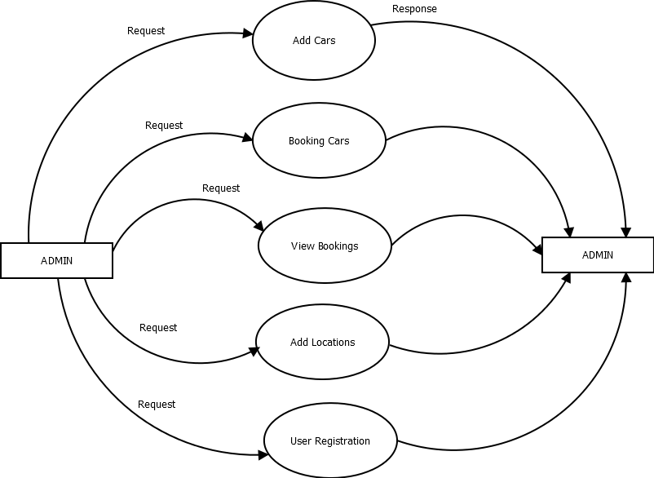

**LEVEL 2 DFD**

ADD CARS

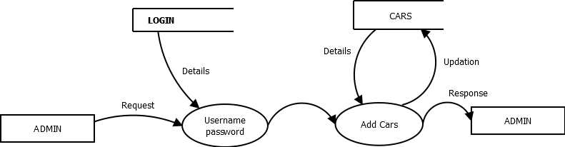

**LEVEL 3 DFD**

BOOKING CARS

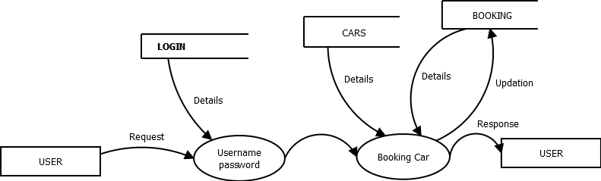

**LEVEL 4 DFD**

VIEW BOOKINGS

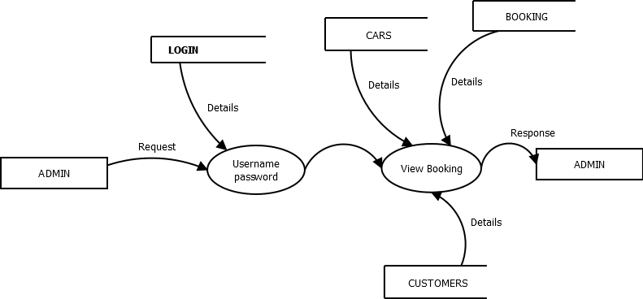

**LEVEL 5 DFD**

ADD LOCATION

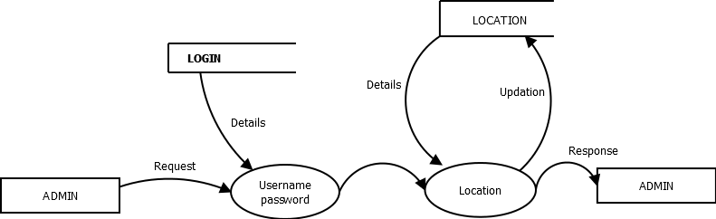

**LEVEL 6 DFD**

USER REGISTRATION

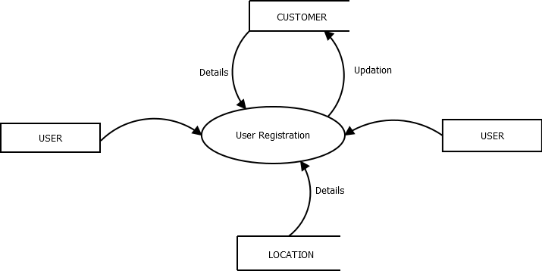

**4.3.2 TABLE DESIGN**

**TABLE- 1:BOOKING**

**PRIMARY KEY: id**

|  |  |  |
| --- | --- | --- |
| **FIELD** | **DATA TYPE** | **DESCRIPTION** |
| id | int(11) | Login id |
| date | Varchar(12) | Date |
| customer_id | Bigint(30) | Customer Id |
| car_id | Bigint(12) | Car Id |
| name | Varchar(30) | Name |
| mobile | Varchar(30) | Mobile Number |
| status | Varchar(30) | Statuses |

**TABLE - 2: CARS**

**PRIMARY KEY: id**

|  |  |  |
| --- | --- | --- |
| **FIELDS** | **DATA TYPE** | **DESCRIPTION** |
| id | Int(30) | Login id |
| carname | Varchar(30) | Car Name |
| imagepath | Varchar(60) | Image Path |
| model | Varchar(30) | Model Number |
| engine | Varchar(40) | Engine |
| length | Bigint(30) | Length |
| width | Bigint(30) | Width |
| height | Bigint(30) | Height |
| seatcap | Bigint(30) | Seating Capacity |
| ng | Bigint(30) | Number Of Gears |
| milege | Bigint(30) | Mileage |
| fueltank | Bigint(30) | Fuel Tank Capacity |
| pws | Varchar(30) | Power Steering |
| amount | Bigint(12) | Amount |

**TABLE- 3:CUSTOMER**

**PRIMARY KEY : id**

|  |  |  |
| --- | --- | --- |
| **FIELDS** | **DATA TYPE** | **DESCRIPTION** |
| id | Int(1) | Id |
| name | Varchar(40) | Name |
| address | Varchar(40) | Address |
| mobile | Bigint(30) | Mobile Number |
| dob | Date | Date Of Birth |
| email | Varchar(30) | Email |
| location | Varchar(30) | Location |
| dis | Varchar(30) | District |
| state | Varchar(30) | State |
| password | Varchar(30) | Password |

**TABLE - 4: LOCATION**

**PRIMARY KEY : id**

|  |  |  |
| --- | --- | --- |
| **FIELDS** | **DATA TYPE** | **DESCRIPTION** |
| id | Int(11) | Id |
| state | Varchar(30) | State |
| dis | Varchar(30) | District |
| loc | Varchar(30) | Location |

**TABLE – 5: MENU PRIMARY KEY : id**

|  |  |  |
| --- | --- | --- |
| **FIELDS** | **DATA TYPE** | **DESCRIPTION** |
| id | Int(9) | Id |
| title | varchar(30) | Title |
| link | Varchar(50) | Link |
| orderid | Int(3) | Order Id |

**TABLE -6:NOTIFICATION**

**PRIMARY KEY:id**

|  |  |  |
| --- | --- | --- |
| **FIELDS** | **DATA TYPE** | **DESCRIPTION** |
| id | Int(11) | Id |
| date | Date | Date |
| Customer_id | bigint(30) | Customer Id |
| msg | varchar(100) | Message |

**SYSTEM TESTING**

# SYSTEM TESTING

Software Testing is the process of executing software in a controlled manner, in order to answer the question - Does the software behave as specified? Software testing is often used in association with the terms verification and validation. Validation is the checking or testing of items, includes software, for conformance and consistency with an associated specification. Software testing is just one kind of verification, which also uses techniques such as reviews, analysis, inspections, and walkthroughs. Validation is the process of checking that what has been specified is what the user actually wanted.

Validation **:** Are we doing the right job?

Verification **:** Are we doing the job right?

Software testing should not be confused with debugging. Debugging is the process of analyzing and localizing bugs when software does not behave as expected. Although the identification of some bugs will be obvious from playing with the software, a methodical approach to software testing is a much more thorough means for identifying bugs.

Other activities which are often associated with software testing are static analysis and dynamic analysis. Static analysis investigates the source code of software, looking for problems and gathering metrics without actually executing the code. Dynamic analysis looks at the behavior of software while it is executing, to provide information such as execution traces, timing profiles, and test coverage information.

## Black box Testing

Black box testing, also called behavioral testing, focuses on the functional requirements of software. This testing approach enables the software engineer to derive the input conditions that will fully exercise all requirements for a program. Black box testing attempts to find the errors like

* Incorrect or missing functions
* Interface errors
* Errors in data structures or external database access
* Behavior or performance errors
* Initialization and termination errors

In Black box testing software is exercised over a full range of inputs and outputs are observed for correctness.

## White box Testing

White box testing is also called Glass box testing is a test case design control; structure of the procedural design to derive test cases using White box testing method, the software engineer can derive the test cases that guarantee that all independent paths within the module have been exercised at least once. Exercise all logic decisions on their true or false sides. Execute all loops at their boundaries and within their operational bounds. Exercise internal data structure to ensure their validity.

The first level of test is unit testing. The purpose of unit testing is to ensure that each program is fully tested.

# UNIT TESTING

In the unit test case will be testing the separate modules of the software. We will carry out black box testing where each module or component of software is tested individually. We will test the component by passing data through it and we will be monitoring data to find the errors. We will make sure that the component work without any troubles. The test primarily is carried out by the programmer who designed and implemented the module. Lead tester is carried out by the programmer who test the modules to finalize the testing

**INTEGRATION TESTING**

In the Integration testing we will combine the different tested modules and we will test the bundle of module. This is to ensure that the entiremodules are working correctly in conjunction with the other modules. Data can be lost across any interface; one module can have adverse effect on another. Sub function when combined, may not produce the desired major function. . Integration testing is a systematic testing for conducting test to uncover errors associated within the interface. The objective is to take unit tested modules and build a program structure. All the modules are combined and tested as a whole. Here correction is difficult because vast expense of the entire program complicate the isolation of causes.

**USER ACCEPTANCE TESTING**

System validation checks for equality of the software in both simulated and live environments. First, the software goes through a phase, in which errors and failures based on simulated user requirements are verified and studies. This is called ALPHA TESTING

**SYSTEM IMPLEMENTATION**

# 6. IMPLEMENTATION

Depends upon the situation, airport can implement all the modules in a single stage or in a phased manner. It should be discussed during the training period. When a hospital is ready with the hardware and has had the training, they can implement the system. Onsite support will provide for implementation. Depending upon the requirements, the team will decide on the duration to stay at the hospital. Implementation can happen in many ways. Followings are some common approaches.

**Live Running Trial**

This involves running a system in a real life environment with the aim of determining what changes may be needed.

**Advantages:** - Early identification of problems (e.g. to software or operational procedures) before the system is implemented. Other benefits such as to encounter any possible bottlenecks in the process, run times, and metrics. Allow setting the pace/scope/timescales, assuming user resource available.

**PHASED IMPLEMENTATION (MODULAR)**

This entails implementing the system in stages, e.g. by department, user, or functionality. In these cases, the system has been implemented for real and it entails a commitment to continue the implementation.

**Advantages: -** less risk than a “big bang” approach.

**PARALLEL RUN**

This involves running the old and new systems simultaneously. The intention is that, this forms part of a real life implementation.

**Advantages: -** Less risky than a “big bang” approach. Useful where it may take some time to create the core data needed for running the new system, e.g. adding new data items to existing records

**Big Bang (Direct)**

This involves implementing the new system in all areas at the same time.

**Advantages: -** May reduce overall support and user costs, by concentrating all effort on a single implementation. Provides a clean change over from old system (computerized or manual) to the new

Monitoring will be done at each of the stages - pre-implementation, training and post implementation etc. A checklist of various tasks and outputs related had been prepared to use in this process.

**Evaluation & Support**

We will decide the system to render the post implementation services and also get feedback.

**SCREEN SHOTS**

**7. SCREEN SHOTS**

**1. LOGIN FORM**

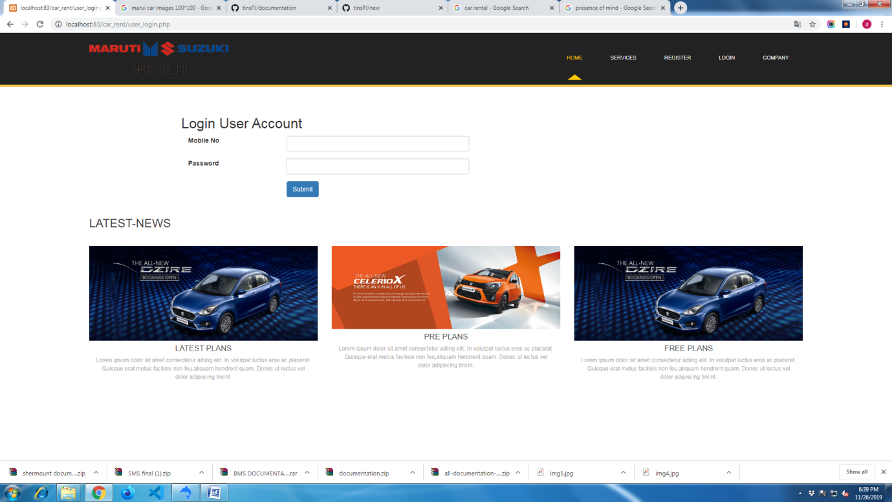

**2. REGISTRATION FORM**

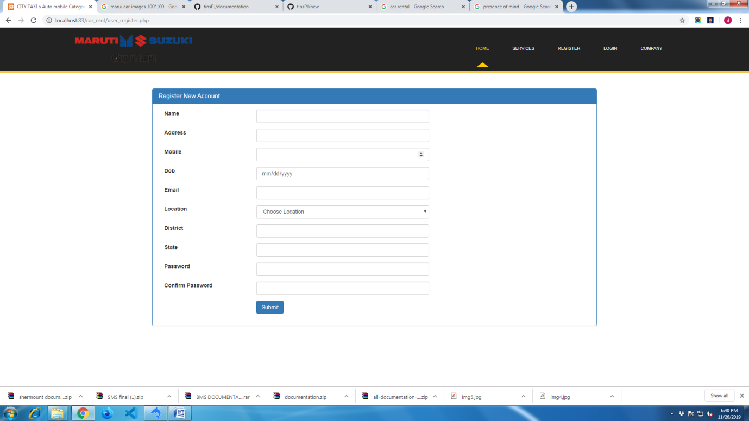

**3. CAR LISTING**

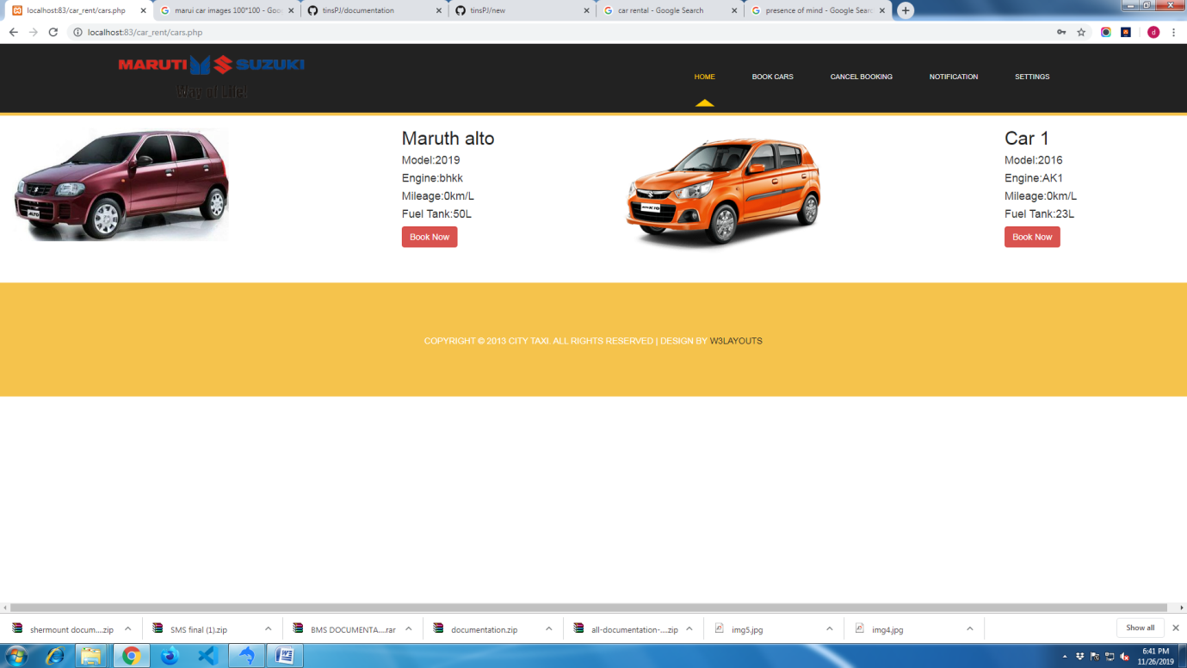

**4. CAR BOOKING**

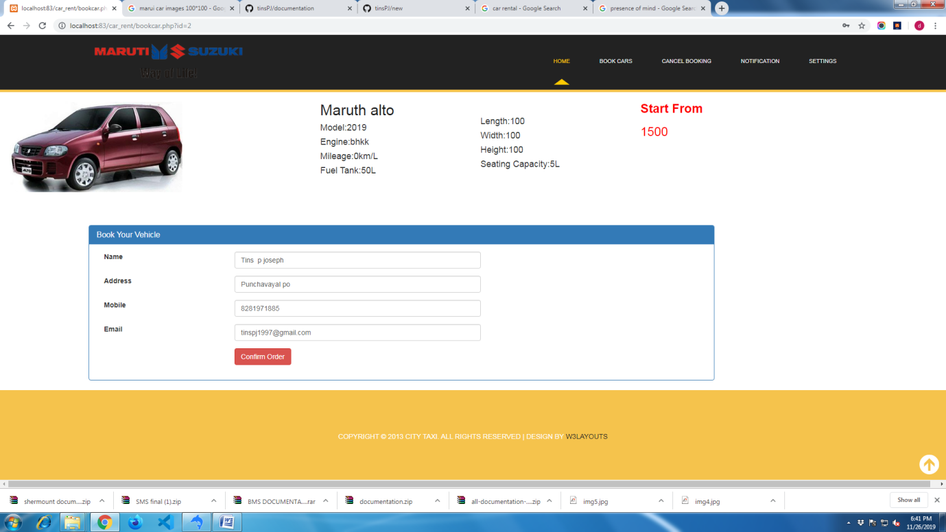

**5. CANCEL BOOKING**

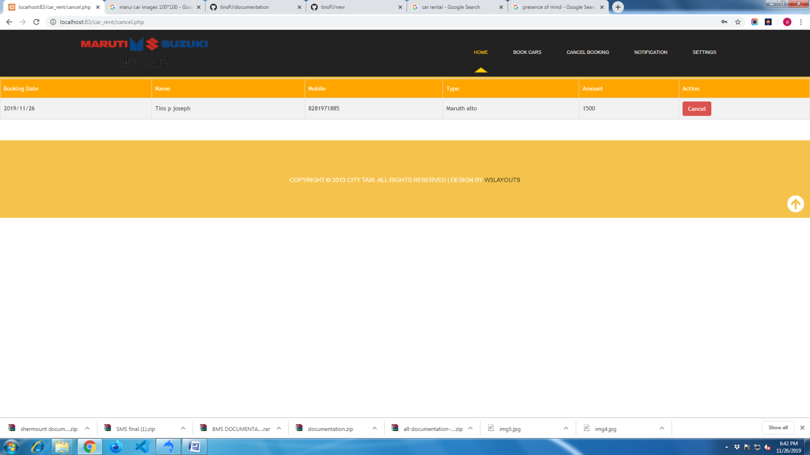

**6.ADD NEW CAR**

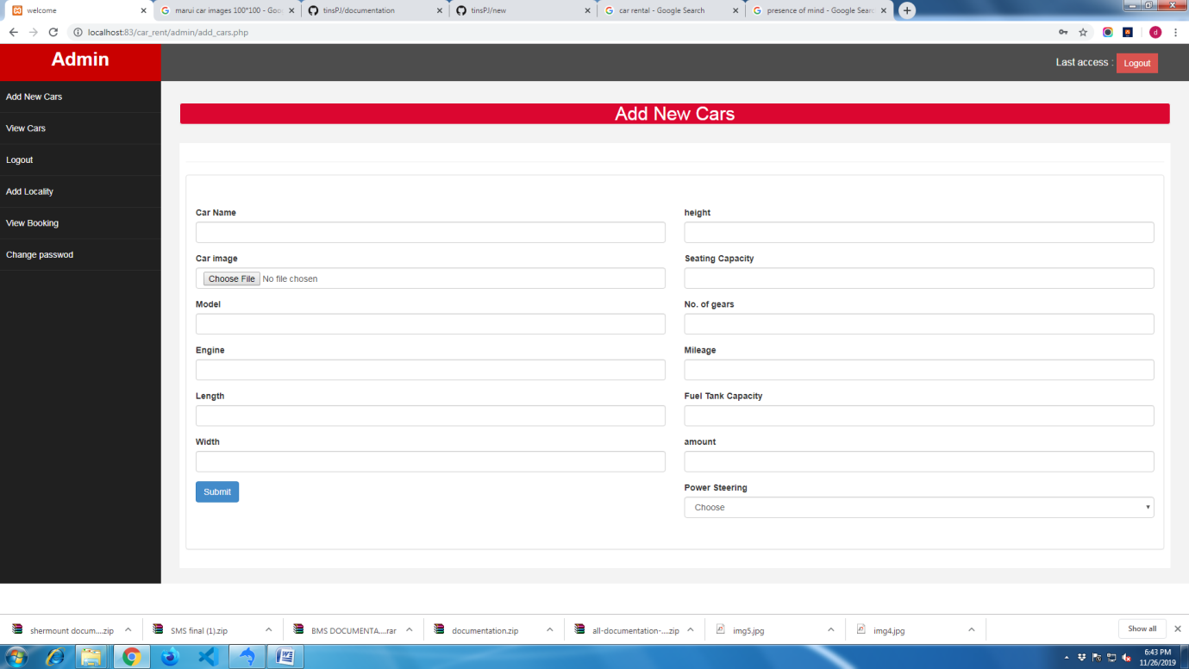

**7. VIEW BOOKING**

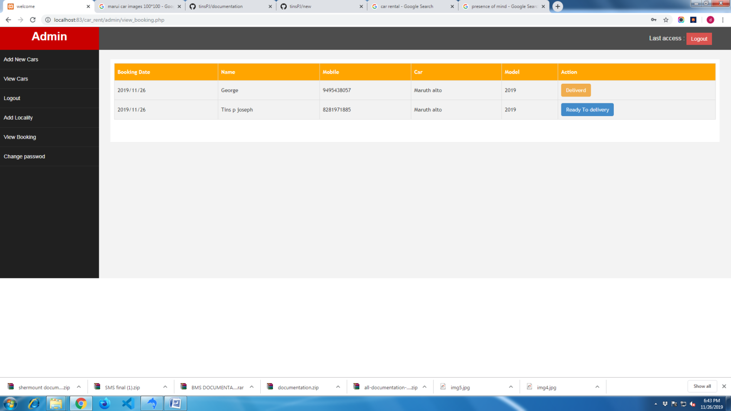

**10. CHANGE PASSWORD**

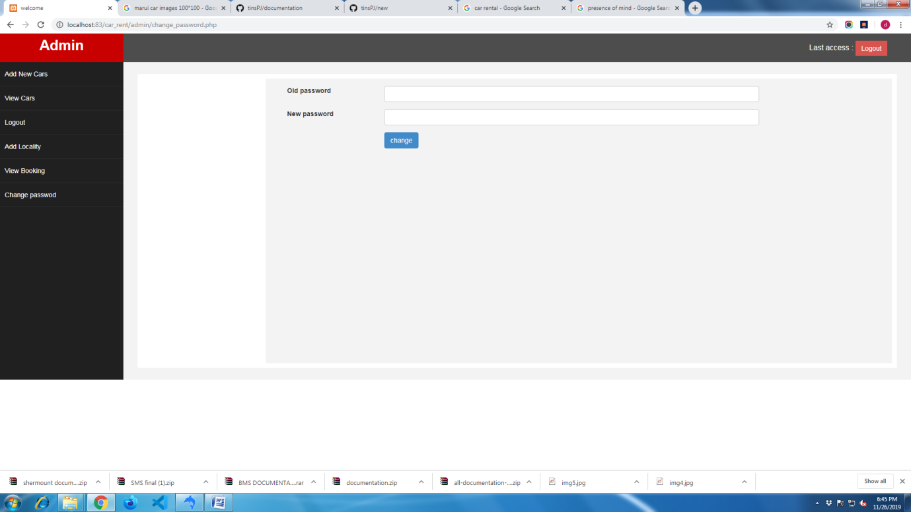

**CONCLUSION**

# 8. CONCLUSION

Car Rental undergoing significant change in structure and operations. The document details all the high level requirements with intent to validate the requirements. This system should be used by rental companies and the users to booking cars. In addition to this, the document also describes the broad scope of the project.

Here, the administrator has entire control over the project. Any number of users can use the system. All modules in the system have been tested with valid data and invalid data and everything work successfully. Thus the system has fulfilled all the objectives identified and is able to replace the existing system. The constraints are met and overcome successfully. The application has been tested with live data and has provided a successful result. Hence the software has proved to work efficiently.

The system is designed in such a way that addition of new modules can be done without much difficulty. The system has been developed as a versatile and user-friendly as possible keeping in mind the advanced features in this technology. Using PHP and MYSQL, the system was developed, and tested with all possible samples of data. As a whole, the system was well planned and designed.The system provides flexibility for incorporating new features, which may be necessary in future.

**BIBLIOGRAPHY**

# 9. BIBLIOGRAPHY

**BOOKS/REFERENCES:**

* Marvin R. Gore & John W. Stubbe, “*introduction to php*”.
* RamezElmasri and Shamakant, “*An Introduction To DBMS”.*
* Peter Norton, “php and mysql”.

**WEBSITES:**

* www.php.net
* www.carrent.com
* www.booking.org